
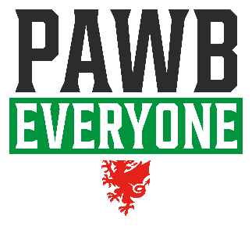



Use the below Action Plan template to record the range of actions you identify for you and your Club when progressing through the steps of the Clwb PAWB Framework.
ACTIONS – WHAT? | TIMESCALE - WHEN? | SUPPORT - WHO? | PROGRESS MADE | STATUS (RAG)
 |  |  |  | Not started | In progress | Completed
E.g Conduct an Equality & Diversity Audit. | End of March | Club coaches & parents | Sent out a communication email with a survey to all parents.

If you require support in completing the Clwb PAWB Action Plan contact PAWB@FAW.Cymru

