

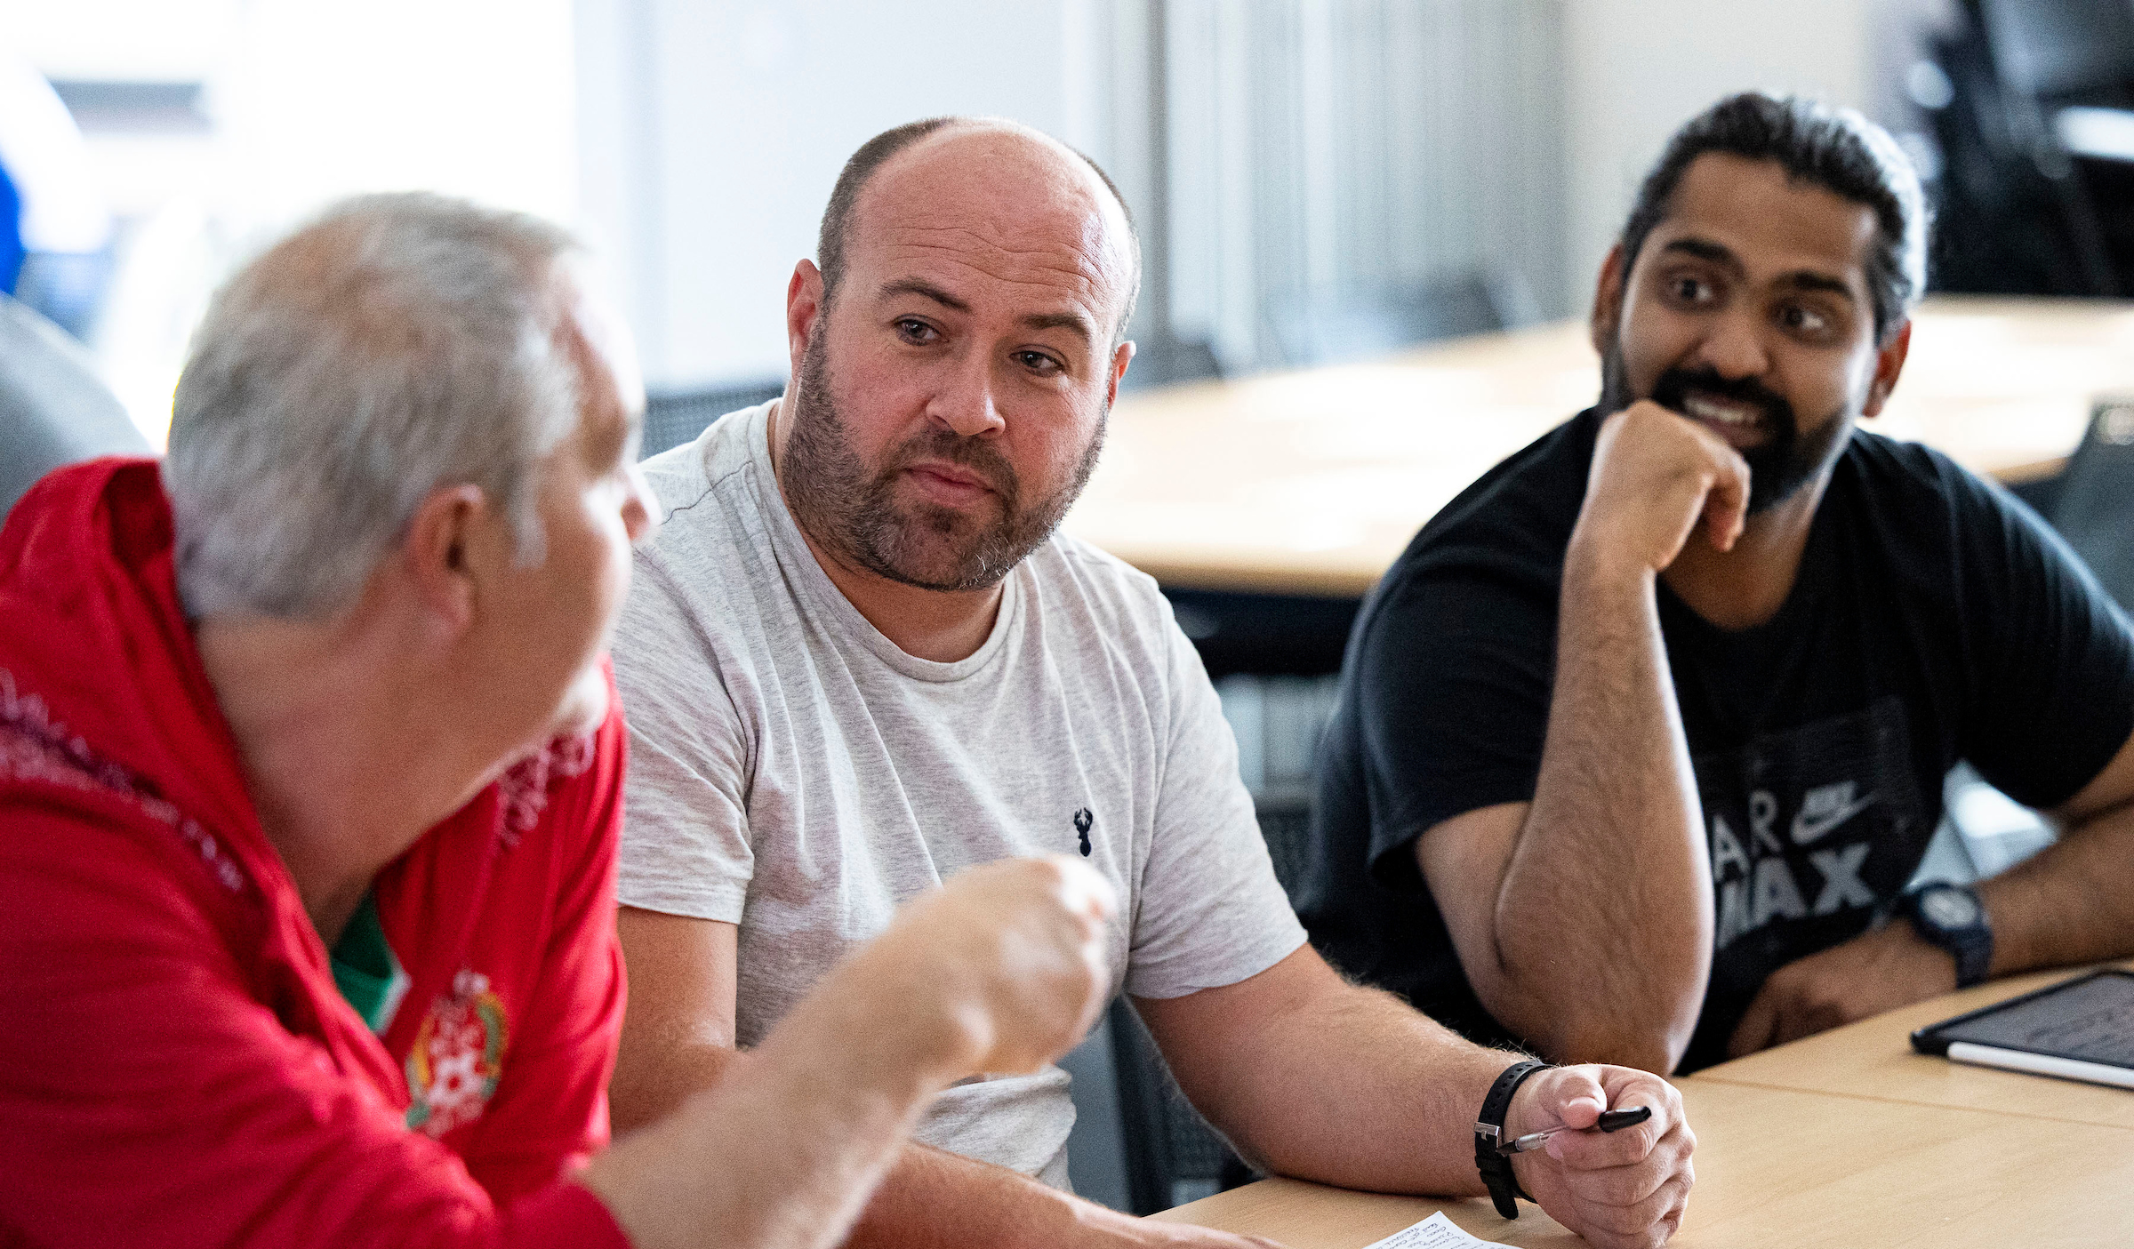

plan reflection

All Club Members should receive regular training on Equality, Diversity, Inclusion and Anti-Discrimination taking a proactive approach to education. Use the below Equality Training Plan Template to plan the Club's education and awareness sessions.
You should assess the Club's level of understanding of various EDI topics and training needs to assist with completing the action plan.
You should keep a register recording members who have attended training sessions and any new members or volunteers of the Club should receive training as part of their induction.
The action plan should be monitored frequently to ensure that any previously delivered training is revalidated where required.

TOPIC –  LEARNING FOCUS | WHEN? | PARTICIPANTS | HOW – WHO WILL DELIVER & WHERE | TYPE OF SESSION | REVALIDATION
E.g Challenging Racism in football (Anti-Racism) | 10th March 7:00 – 8:00 PM | Club coaches | Show Racism the Red Card – leisure centre hall. | Workshop – in person | Next season (Annually)

If you require support in completing the Equality Training Plan contact PAWB@FAW.Cymru

